#### **Scope:** The purpose of this project is to analyze enrollment trends for public Texas universities over the past few years (e.g., 2019–2023). Tools used in this project: SQL and Python.

#### **Data Manipulation Process:**

1. **Data Acquisition:**
   * Downloaded the enrollment report for public Texas universities from the Texas Higher Education Accountability System website.
2. **Data Preparation:**
   * Transformed the Excel file into CSV format.
   * Cleaned the file to remove special characters, unused headers, and unnecessary comments for importing into MySQL.
3. **Database Setup (MySQL Workbench):**
   * Imported the cleaned CSV report into MySQL Workbench.
   * Created tables corresponding to the CSV structure using SQL commands.
   * Ran initial queries to confirm data integrity and ensure correct loading of rows.
4. **Data Analysis (SQL Queries):**
   * Performed various SQL queries to answer the research questions, such as identifying enrollment trends, calculating percentage changes, and correlating data between different years and ethnicity groups.
5. **Data Visualization (Python):**
   * Exported the SQL query results as CSV files.
   * Created visual representations (bar charts, line graphs, dot plots) using Python's Matplotlib and Pandas Libraries to better illustrate the trends and correlations in the data.
6. **Final Output:**
   * Analyzed the data and generated visual insights.
   * All SQL code and Python scripts were uploaded to GitHub.

#### **Questions to Answer (Queries):**

1. Enrollment growth or decline by institution (UT-San Antonio) per year (2021-2023):

* *SQL Query 1*: Analyzed the total enrollment for UT-San Antonio from 2021 to 2023 to observe trends in growth or decline.

1. Identify institutions with significant growth or decline overall:

* *SQL Query 2*: Calculated the maximum and minimum enrollment for each institution and ranked them by their overall enrollment change from 2021 to 2023.

1. Calculate the percentage change in enrollment for each university from 2021 to 2023:

* *SQL Query 3*: Determined the percentage change in enrollment for each university between 2021 and 2023, to highlight significant growth or loss in student numbers.

1. Correlation between enrollment and ethnicity over time:

* *SQL Query 4*: Summed the total enrollment across different ethnicities over time (2021-2023) and analyzed the correlation between changes in enrollment and ethnicity.

#### **Analysis & Outcome**

**Query 1: Enrollment growth or decline by institution per year:**

* For this example we looked at UT-San Antonio. Based on the bar charts, we observed that UT-San Antonio experienced a decline in 2022 but recovered by 2023, surpassing their 2021 levels. Other universities, like Texas A&M, showed consistent growth over the three-year period.

| institution_name | academic_year | total |
| --- | --- | --- |
| Texas A&M University | fall_2021 | 66057 |
| Texas A&M University | fall_2022 | 67165 |
| Texas A&M University | fall_2023 | 69517 |

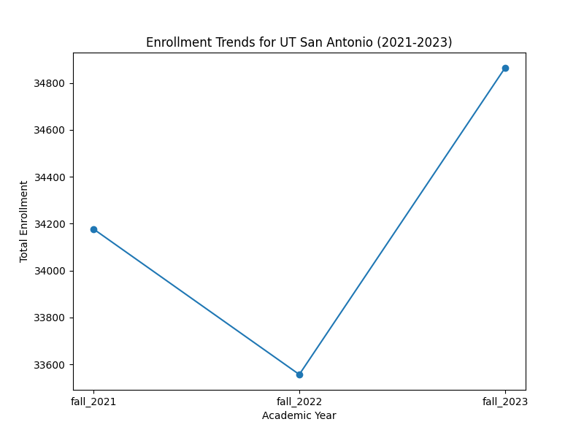

*Enrollment trends for The University of Texas - San Antonio (2021-2023)*

**Query 2: Significant growth or decline overall:**

* The University of North Texas saw a significant increase in enrollment, with an overall growth of 4556 students between 2021 and 2023. On the other hand, Texas A&M University-Texarkana saw the largest decline in the same period.

| institution_name | max_enrollment | min_enrollment | enrollment_change |
| --- | --- | --- | --- |
| University of North Texas | 46724 | 42168 | 4556 |
| Texas A&M University-Texarkana | 2078 | 2056 | 22 |

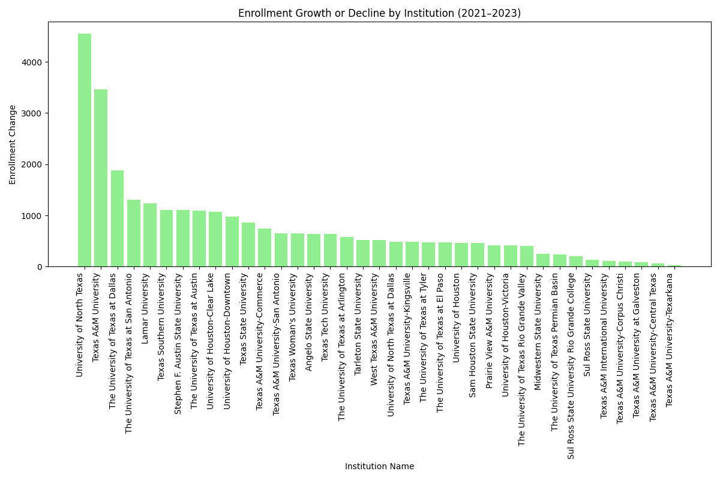

*Overall significant growth or decline (2021-2023)*

**Query 3: Percentage change in enrollment:**

* The percentage change calculation highlights that while some institutions experienced slight variations, others had more extreme fluctuations, such as Sul Ross State University Rio Grande College with a -23.5714 drop in enrollment between 2021 and 2023. Additionally, Texas Southern University had an increase in enrollment at 12.5598 percent between 2021 and 2023.

| institution_name | academic_year | enrollment_percentage_change |
| --- | --- | --- |
| Sul Ross State University Rio Grande College | fall_2023 | -23.5714 |
| Texas Southern University | fall_2023 | 12.5598 |

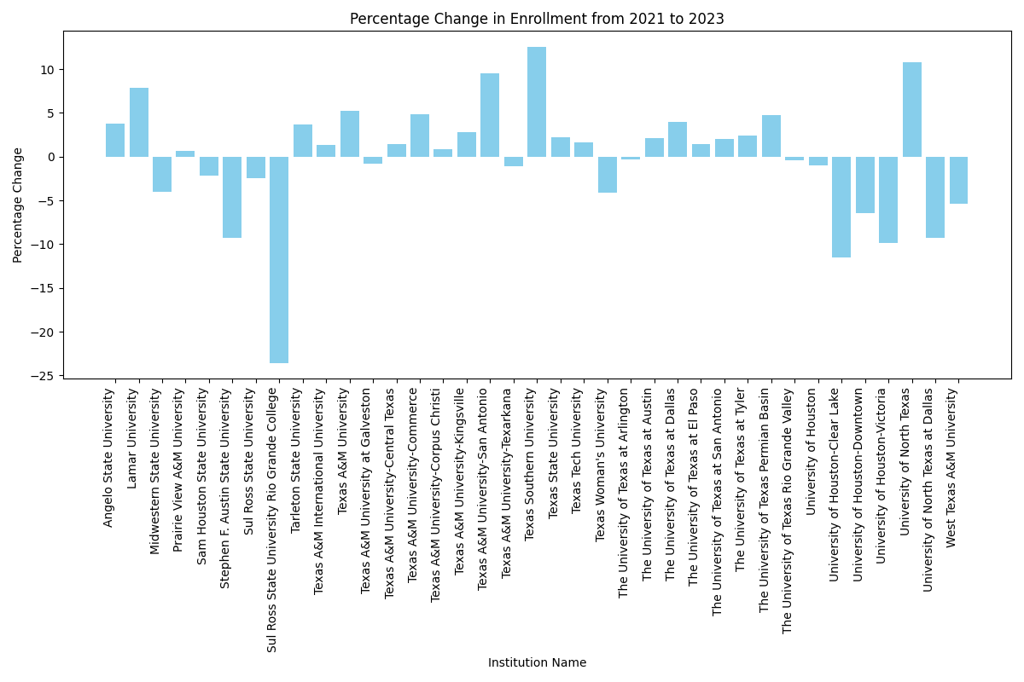

*Percentage of change in enrollment (2021-2023)*

**Query 4: Correlation between enrollment and ethnicity:**

* The correlation analysis shows that Hispanic and White student populations grew over the years, whereas some other ethnic groups, such as African American students, remained relatively stable.

| academic_year | total_white | total_african_american | total_hispanic | total_asian | total_international | total_other |
| --- | --- | --- | --- | --- | --- | --- |
| fall_2021 | 228066 | 78518 | 241762 | 58518 | 37321 | 21015 |
| fall_2022 | 216968 | 77687 | 243039 | 59507 | 46761 | 22349 |
| fall_2023 | 212042 | 79403 | 249603 | 61478 | 50046 | 23871 |

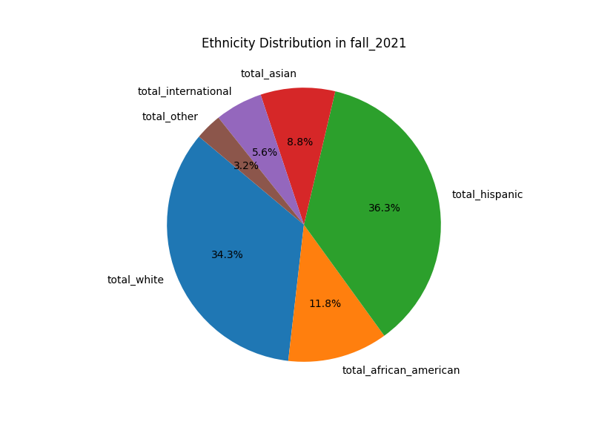

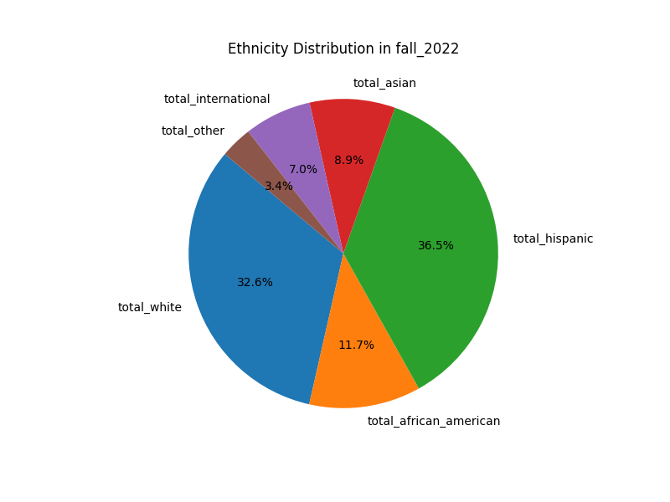

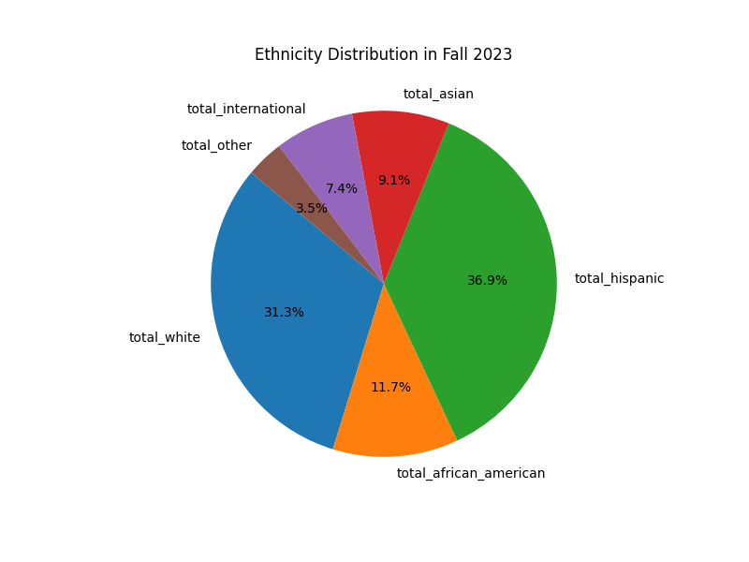

*Correlation between enrollment and ethnicity (2021-2023)*

#### **Conclusion:**

The analysis reveals interesting trends in enrollment at public Texas universities between 2021 and 2023. Notably, universities that suffered a decline in 2022 managed to recover by 2023, with some institutions surpassing their previous enrollment highs. Ethnic diversity in enrollment patterns also highlighted significant growth among Hispanic and international students.

Future work could involve adding graduation rates and exploring the correlation between enrollment and student outcomes, such as graduation rates, to provide a more holistic understanding of institutional performance.